Basic Structure (Boilerplate)
Every program has an "Entry Point" where execution begins
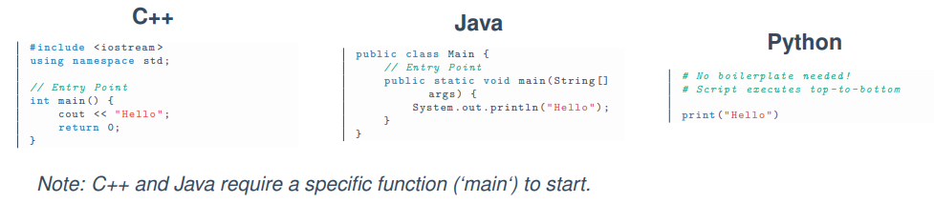

What is a Variable?

Definition:
A Variable is a named storage location in the computer’s memory (RAM) that is used to store a value.

Box Analogy (Easy Understanding):
- Label Name → Variable Name (e.g., age)
- Contents → Stored Value (e.g., 25)
- Box Size → Data Type (e.g., Integer)
- Address → Memory Location (e.g., 0x104A)
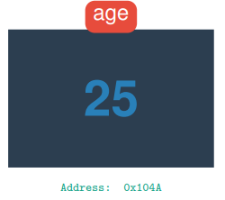
Identifiers (Naming Variables)

Definition:
An Identifier is the name given to a variable, function, or class.